Brainstorm : https://www.data.gov.in/catalog/people-plan-campaign-planning-data
Problem Statement- People Plan Campaign Planning Data
Domain - Data Science
Objective - To check whether Gram panchayats were completely approved from total gram panchayats(0 - completely approved ,1- Not completely Approved)
Outcome - districtcode,totalGp,Sabhaheld,GpdpApproved,GpdpUpload (Inputs) IsdpFullyApproved (Yes or No)
Machine Learning Problem Type
- Supervised Learning – Classification
Feature Description
Feature Name | Data Type | Description
stateCode | Numeric | state code
stateName | Categorical | State name
districtCode | Numeric | District code
districtName | Categorical | District name
finYear | Categorical | Financial Year
totalGP | Numeric | Total Gram Panchayats
sabhaHeld | Numeric | Gram sabha meetings
gpdpApproved | Numeric | Gram panchayats Approved
gpdpUpload | Numeric | Docs Uploaded for GP's Approval
date updated | date | Data updated
Target Variable:
Name: gpdpApproved ('is_gpdp_fully_approved') - Binary Classification (0 or 1)
Description: Gram Panchayats Approved
Prediction Goal: To check whether Gram panchayats were completely approved from total gram panchayats(0 - completely approved ,1- Not completely Approved)
Imported required libraries for performing EDA,data preprocessing ,feature selection and data manipulation as well and loaded the dataset as well for analysing .
Verified Null values using isnull and summed up the values , Its Displaying as 0 .
No Null values Present
Checked for duplicate values using duplicated and stored the result in another variable .
Used Value_counts to display the variable result.
Correlation Analysis
State and District are quite Correlated but they are extremely weakly correlated with other columns.
TotalGP,sabhaheld and gpdpApproved are positively Correlated and they are badly correlated with State and District columns
gpdpApproved and gpdpUpload are well correlated and also having a better correlation with TotalGP and sabhaheld
Other columns like district name, state name , financial year and data updated are in categorical columns.
Visualizations:

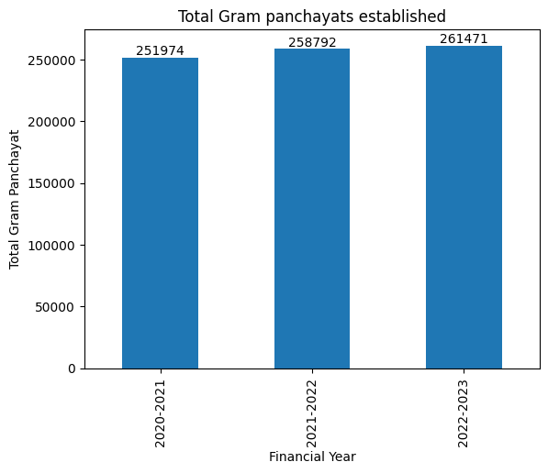
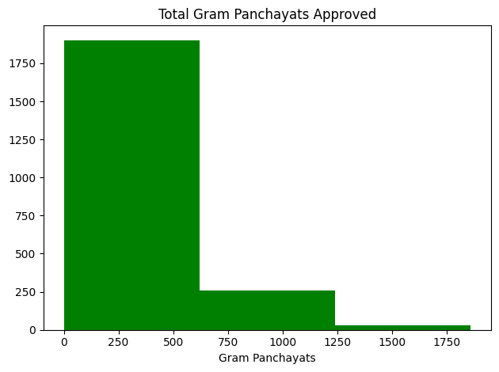
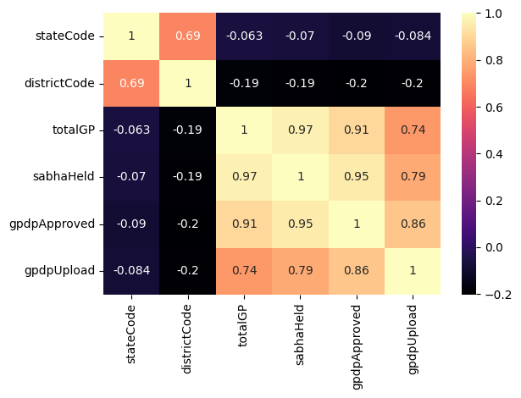
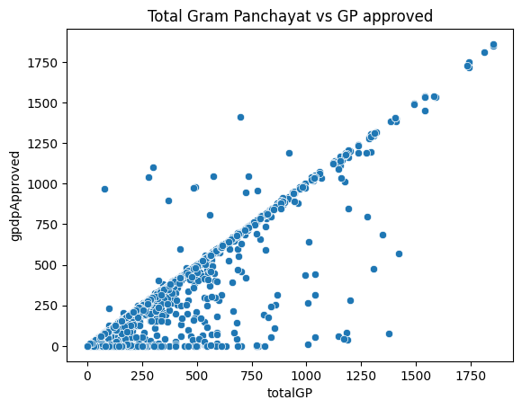
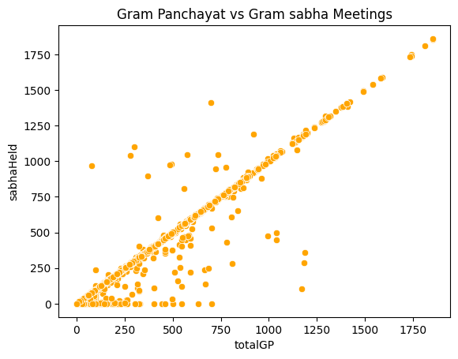
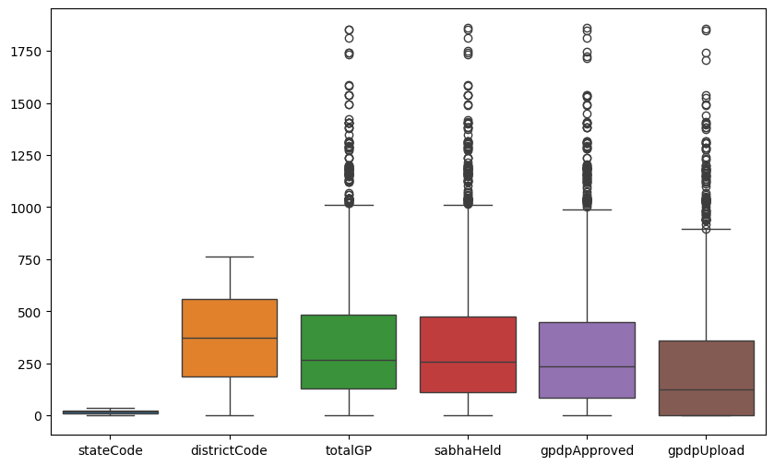
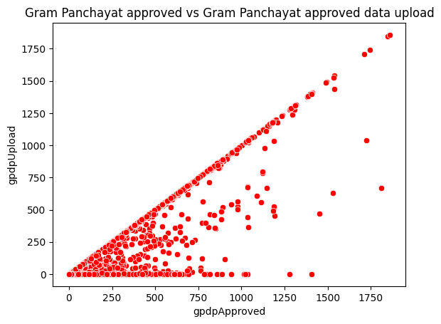

Summarize important findings.
There are some outliers on major features related to GP and GS
approved Gram Panchayats are more than total GP which is either because of any supplementary funds allocated by the government due to floods or any data error .
In the financial year of 2022 - 2023 , major gram panchayats were established.
There are no missing or null values in the Data set.
There are no duplicate values as well .
Data are seems to be reliable and useful (Not Looking like outliers)in Zscore
Skewness Before Transformation : Most of the values are closer to zero . So Implemented square root
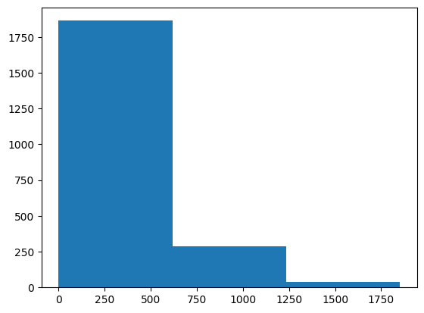
After transformation
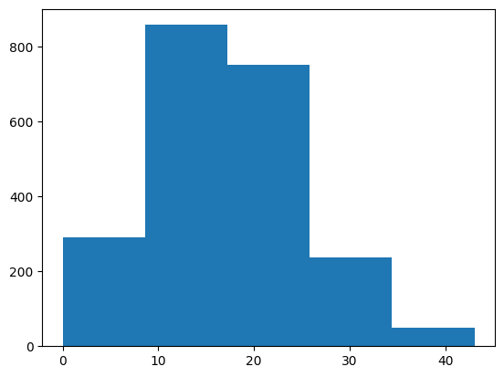
Explain any new features created. - Created isdpFullyapproved features based on totalgp and gpdpapproved features to check whether all of the gram panchayats for each and every district is fully approved. (0 or 1)
Selected Features : Statecode,finyear,TotalGp,Gpdpupload and sabhaheld.
After selecting the features with the help of selectkbest method and then started building the models with logistic regression,Decision Tree, random forest , KNN and SVC.Later, Evaluated the models using classifier metrics like accuracy, precision, recall , F1- Score and ROC-AUC

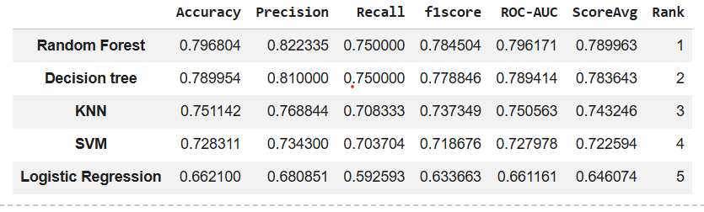
These are the metrics scores for all the models along with the rank . calculated the average score for all the metrics corresponding to each model and then ranked them .
Best Model Selection - Random Forest is selected because it got a very good score comparatively with other models on average .
Strengths :
It picks the results from different trees .
Single decision trees easily overfit but random forest averages out individual errors across many uncorrelated trees.It manages with a thousand input dimensions without feature reduction.Outliers or random noise will not affect the prediction of random forest because it affects only the tiny parts of trees in the forest if that really scores low variance ignored .
It works well both in Classification and Regression algorithms.
Overfitting / Underfitting Analysis
Training Performance - 0.9994292237442922
Training data Performed really well of accuracy score 99%
Testing Performance - 0.7945205479452054
Training accuracy combined with testing accuracy means random forest essentially memorized the training data instead of finding out the learning pattern because it has got the absolute differences of 20% . As training performance is high , we can say , it's severely Overfitting .
Generalization capability - Performed hyperparameter tuning for the best configuration setting to balance bias - Variance .As Model predicts high variance with low bias (Overfitting),performing hyperparameter tuning with gridSearchCrossvalidation results the parameter with values below
n_estimators=100,max_depth=12,min_samples_split=20,max_features='sqrt',min_samples_leaf=10 which minimizes the training accuracy and balances the both training and testing accuracy with 0.8361872146118722 and 0.8036529680365296.This model has achieved good generalization capability.The training score with 83.6 has 3.2 total difference with the testing score which successfully prevented my model from memorizing the noise but allowed me to maintain predictive performance on unseen data .
Overfitting - A minimal Gap with 3.2 low variance
Underfitting - passed and scores are strong with low bias .

